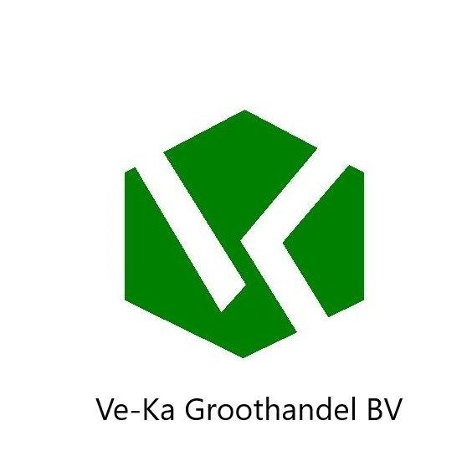Kaolin C-3090

Grolleg

Ve-ka groothandel .b.v
Industrieweg 7a
65621 BD Dreumel
Tel: 0487 – 571667
info@ve-ka .nl
www.ve-ka.nl min.
0.68
1.67

Application(s)
Table ware , tiles , glazes and engobe
Product specification, 5
52
value max.

Chemical Analyse (%)
FezO3K2O 0.75 0,82
1.85 2.03
0.7

Practicle size analyse (%)

>5,3µm 0.05
>8µm 8 11
>2µm 48 64

Modulus of rupture( MN.m-2) AT
80% RH 1.0 1.3

Typical properties chemical analysis(%) 49.00
Sio2 36.00
Al2O3 0.02
TiO2 0.10
Na2O Cao 0.06
MgO 0.30
L.O.1. 12.00

Casting data(%)
Casting concentration (mass% solids) 61.00
P84 demand (mass% ) 0.50
Casting rate (mm2,min-1) 0.50

Fired properties (%) Brightness At 1180°C At 1280°C
86.00 84.00
Water absorption 13.00 6.50
Linear contraction 9.00 13.00
_______________________________________________________________________________ product form &standard

Packing:
Powder lumps big bag 25-50 bags bulk
The Tipical date values do not represent a specification. The date quoted are determined by the use of Imerys Standard Test Methods , copies of witch will be supplied on request. Every precaution, is taken in production to ensure the products conform to our published data. Since the products are based on naturally occurring materials , we reserve the right to change these data should it become necessary. Sales are accordance with oJr “ conditions of sale” copies will be supplied on request.

