BALL CLAY CH102

Hyplas 71

APPLICATION
Tableware

PRODUCT SPECIFICATION
CHEMICAL ANALYSIS {%)  SiOz | Min. 68 | Value 71 | Max.
 | 16.5 | 18.5 | 21
 | 0.6 | 0.8 | 1.0
Ti0₂ | 1.4 | 1.6 | 1.8
 | 1.4 | 1.9 | 2.2
L.0.1. | 4.7 |  | 5.8
PHYSICAL PROPERTJES (m².g-1)
Specific surface area | 14 | 19 | 24

December 2014

Seventh Edition
This version supersedes the version dated November 2008

73

TYPICAL PROPERTIES CHEMICAL ANALYSIS (%)
cao

M O
Carbon
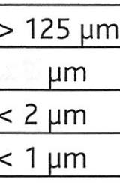
PARTICLE SIZE ANALYSIS (%)

< 5

< 0.5 µm
MODULUS OF RUPTURE (MN.m-2)

Dried at 110 °C
FIRED PROPERTIES {%)
Brightness
Water absorption Linear contraction

Value 0.3
0.1
0.3
0.2

0.7
72
58
48
39

7.0
1110°c
48.0
5.0
4.8
Supplier Site
Ve-ka b.v..
Industrieweg 7a
6621 BD Dreumel
Tel. +31(0)487 571667

Email
info@ve-ka.nl

Website:
www.ve-ka.nl

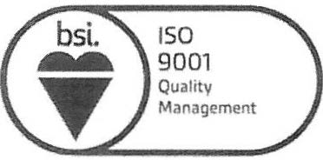
FM 14752

PRODUCT FORM & STANDARD PACKAGING
Powder, shredded
Big bag, 25-50 kg bags, bulk

Typical data values do not represent a specification. The data quoted are determined by the use of lmerys Standard Test Methods, copies of which will be supplied on request. Every precaution is taken in production to ensure the products conform to our published data. Since the products are based on naturally occurring materials, we reserve the right to change these data should it become necessary. Sales are in accordance with our "Conditions of Sale", copies of which will be supplied on request.

